Dynamic Preprocessing Algorithm for Handwritten Prescription Images - Boosting OCR Accuracy

Atharva Joshi¹, Shailaja Pede², Aditya Metkar³, and Prathmesh Kolekar⁴

^{1,2,3,4}Pimpri Chinchwad College Of Engineering , Pune ,SPPU, India
atharvacjoshi11@gmail.com, pede.shailaja@gmail.com
{prathmesh.kolekar,aditya.metkar }21@pccoepune.org

Abstract. We introduce a Dynamic Preprocessing Algorithm for Handwritten Prescription Images, designed to optimize Optical Character Recognition (OCR) by improving text extraction accuracy and computational efficiency. The preprocessing method includes Contrast Limited Adaptive Histogram Equalization (CLAHE) for contrast enhancement, median filtering and Gaussian blurring for noise reduction. Along with this it uses a hybrid thresholding technique which we built that dynamically selects between adaptive thresholding and Otsu’s method based on local contrast levels. Additionally, we have applied morphological processing techniques to refine text segmentation by removing noise and enhancing character structures.
This algorithm is implemented within a Python Flask-based middleware, where it reduces the average image size by 90% (from 220 KB to 22 KB), introducing only 0.4 seconds of processing time per image while also significantly decreasing the Gemini 2.0 Flash API round trip time from 4.6 to 4.0 seconds. These optimizations result in an increase in OCR accuracy from 74.4% to 86.1% ,which shows its effectiveness in enhancing prescription digitization. The system integrates Flutter for a user-friendly interface, Firebase for authentication, and MongoDB for data storage and retrieval.
Apart from simple text extraction, our preprocessing pipeline further contributes to a more efficient and accurate prescription management system, by trying to enable automated medication reminders, streamline the prescription tracking, and by adding real-time health monitoring. By addressing common challenges in handwritten prescription detection, our approach tries to improve the current digital healthcare solutions while maintaining efficiency.

Keywords: OCR Preprocessing, Handwritten Prescription Recognition, CLAHE, Otsu’s Method, Image Denoising, Morphological Processing, AI-powered Text Extraction, Digital Healthcare, Prescription Management System, OCR Accuracy Optimization.

1 Introduction
The convergence of artificial intelligence (AI) and digital healthcare solutions has revolutionized medicine, bridging inefficiencies in prescription handling and patient compliance. Misinterpretation, loss, or mishandling of handwritten prescriptions remains one of the biggest issues facing healthcare, resulting in medication non-adherence and adverse health consequences. Research has identified that misreading handwritten medical prescriptions can lead to serious medical errors and patient injuries, and this calls for robust digital technologies to recognize and process prescriptions.
A Smart Prescription Management App is the subject of this paper, and it is an end-to-end digital healthcare system that handles, stores, and digitizes handwritten prescriptions with the help of AI-based OCR.For improved patient compliance and medical management, our system provides medicine intake reminders and automatic refills and updates the centralized repository of prescriptions with patient details. Using AI-based OCR, the app extracts key information from handwritten prescriptions, such as hospital name, prescription date, drug names, dosage, intake regimen, frequency, and doctor and patient demographics.
2 Related Work
Digitalizing prescriptions is one of the great frontiers of healthcare innovation. Scientists have worked on algorithms and systems to decode handwritten prescriptions, track medication adherence, and fold this data into holistic healthcare systems. Joseph and Sundar's DocPresRec system (2022) automates handwriting recognition of prescriptions, breaking a critical barrier to digitizing healthcare. Dhande and Kharat (2017) targeted cursive English handwriting. Lee et al. (2020) and Rani et al. (2022) incorporated physician signature verification. Kumar et al. (2022) showed how prescription information could be used in real-time health monitoring systems, and Wang et al. (2023) connected this technology to medication reminder systems.
Sharma et al. (2021) created an AI system that corrects errors in medical terminology. Pavithiran et al. (2022) addressed multilingual prescription recognition. Shaik (2024) and Achkar (2019) used Convolutional Recurrent Neural Networks (CRNNs) for improved accuracy. The Journal of Medical Informatics Research (JMIR) (2022) focused on post-processing techniques, with Hassan et al. (2021) demonstrating how these techniques enhance system reliability.

3 Proposed Solution
The Smart Prescription Management App is a combination of mobile application development frameworks, cloud services, and AI-driven text recognition technologies to efficiently process, structure, manage and store the prescription data. This Section describes the System Architecture and methodologies used while developing the App.

3.1 System Architecture
The Smart Prescription Management App follows a modular architecture, incorporating OCR-based text extraction, AI-driven analysis, Firebase Authentication and MongoDB Cloud Storage. Similar architectures have been proposed in prior works, where modularity ensures scalability and efficiency in handling real-time medical data [9].The system is divided into two primary components:
1. Frontend (User Interface & Experience):
Flutter is used for the development of Frontend which ensures a seamless, cross-platform experience on Android and iOS.The UI is minimalistic, user-friendly, and intuitive, aligning with best practices in digital health applications, where usability plays a crucial role in adoption [10].Users can view extracted prescription details, update medication reminders, and track refill schedules effortlessly.The application is responsible for triggering automated medication reminders and tracking refill cycles based on the extracted prescription schedule.
2. Backend (Processing & Storage):
A Flask-based API acts as an intermediary between the mobile application and Gemini 2.0 Flash API for OCR processing.The system Preprocesses the incoming image with the help of dynamic thresholding and extracts medication names, dosage, frequency, and duration from hand- written prescriptions.Extracted prescription data is structured and stored securely in MongoDB, a cloud- based NoSQL database with the help of Llama 3.3 70B Model which uses function calling to interact with the MongoDB Server.A centralized storage system ensures that users can access their past medical records and share prescription data with healthcare providers securely.
By integrating OCR, and real-time health tracking, the system bridges the gap between traditional prescription handling and digital healthcare automation. The proposed solution significantly enhances medication adherence, prescription accessibility, and proactive health management.
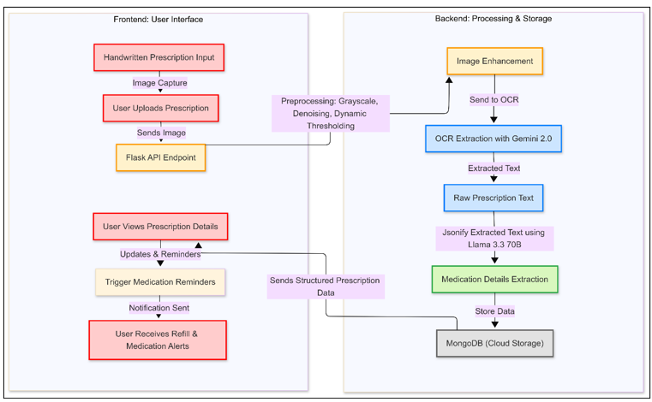
Fig. 1. Frontend Backend Interaction

3.2 Preprocessing Algorithm

The OCR engine, powered by Gemini 2.0 Flash API, extracts key details such as:
- Doctor Name, Patient Name, Hospital Name
- Date of Prescription & Patient Demographics
- List of Medications, Dosage, and Schedule

Before Performing OCR, the Prescription undergoes Preprocessing where the image is first converted to grayscale then the noise from the image is eradicated using a Gaussian Filter followed by Adaptive Thresholding as a result of these the size of the image also gets reduced which is beneficial as we send the image as payload to the Gemini API.
The extracted text is then verified with the help of LLMs having access to the internet to eliminate errors, ambiguities, and formatting inconsistencies before being structured into a database-friendly format. Prior studies have demonstrated that OCR-based prescription recognition systems, when combined with error-correction mechanisms, can significantly improve the accuracy of digitized medical records [12]

Algorithm: Dynamic OCR Preprocessing for Handwritten Prescription Images
Input:
Image I (RGB or grayscale) defined over domain Ω.
Parameters:
CLAHE: clipLimit, tile size (Tx,Ty)
Median Filter: window W_m (e.g.,3×33×33×3)
Gaussian Blur: kernel size K, standard deviation σ
Adaptive Thresholding: window W_a (odd dimension), constant CCC
Std. Threshold: σ_th (to choose thresholding method)
Morphological Element: B (e.g., 3×33 \times 33×3 ones)
Output:
Binary image B_"final" (text pixels separated from the background)

Step 1: Grayscale Conversion

If I is RGB, convert to grayscale $I_{g}$:
$$\begin{aligned}\begin{aligned}I_{g}\left(x,y\right)=0.299 I_{R}\left(x,y\right)+0.587 I_{G}\left(x,y\right)+0.114 I_{B}\left(x,y\right),∀\left(x,y\right)∈Ω. \end{aligned}\#\left(1\right)\end{aligned}$$

Step 2: Contrast Enhancement with CLAHE

Divide I_g into tiles of size $T_{x} * T_{y}$
For each tile:
Compute histogram H and clip at T_clip.
Compute:
$$\begin{aligned}\begin{aligned}CDF\left(i\right)=\frac{\sum_{j=0}^{i}{H\left(j\right)}}{N},\#\end{aligned} \#\left(2\right)\end{aligned}$$

N="number of pixels."
Map pixel value p to:
$$\begin{aligned}\begin{aligned}p^{'}=\text{round}\left[\left(L-1\right)\frac{CDF\left(p\right)-CDF_{\text{min}}}{1-CDF_{\text{min}}}\right], \#\end{aligned}\#\left(3\right)\end{aligned}$$

"where " L" is gray levels (typically 256)."
Bilinearly interpolate between tiles to form $I_{e}$

Step 3: Denoising
Median Filter:
$$\begin{aligned}\begin{aligned}\left(I_{m}\left(x,y\right)=median\{I_{e}\left(i,j\right) ∣ \left(i,j\right)∈W_{m}\left(x,y\right)\} \right) \#\end{aligned}\#\left(4\right)\end{aligned}$$

Gaussian Blur:
Define:
$$\begin{aligned}\begin{aligned}G\left(x,y\right)=\frac{1}{2πσ^{2}}\exp\left(-\frac{x^{2}+y^{2}}{2σ^{2}}\right) \#\end{aligned}\#\left(5\right)\end{aligned}$$
then compute:
$$\begin{aligned}\begin{aligned}I_{b}\left(x,y\right)=\left(Im*G\right)\left(x,y\right).\end{aligned} \#\left(6\right)\end{aligned}$$

Step 4: Statistical Analysis
Compute mean μ and standard deviation σ_I of I_b:

$$\begin{aligned}\begin{aligned}μ=\frac{1}{\left|Ω\right|}\sum_{\left(x,y\right)∈Ω}{I_{b}\left(x,y\right)} \#\end{aligned}\#\left(7\right)\end{aligned}$$
$$\begin{aligned}\begin{aligned}σ_{I}=\sqrt{\frac{1}{\left|Ω\right|}\sum_{\left(x,y\right)∈Ω}{{\left(I_{b}\left(x,y\right)-μ\right)}^{2 }}}\#\#\#\end{aligned}\#\left(8\right)\end{aligned}$$

Step 5: Dynamic Thresholding
If σI<σth (low contrast), use adaptive thresholding.
Else, apply Otsu’s global thresholding.
Adaptive Thresholding:
For each pixel (x,y),compute the local mean m(x,y) over the adaptive window W_a:
$$\begin{aligned}\begin{aligned}m\left(x,y\right)=\frac{1}{\left|W_{a}\right|}\sum_{\left(i,j\right)∈W_{a}\left(x,y\right)}{I_{b}\left(i,j\right)} \#\end{aligned}\#\left(9\right)\end{aligned}$$
Then threshold:
$$\begin{aligned}\begin{aligned}B\left(x,y\right)=\left\{ \begin{matrix}1 Ib\left(x,y\right)>m\left(x,y\right)-C \\ 0 Otherwise\end{matrix}\right. \#\end{aligned}\#\left(10\right)\end{aligned}$$

Otsu’s method:
Otsu’s method finds the best threshold $T^{*}$ by minimizing the difference within two-pixel groups: those below and above T.
It calculates the probability (ω0,ω1)and variance $\left(σ_{0}^{2},σ_{1}^{2}\right)$ of both groups.
It picks the${ T}^{*}$ that results in the smallest combined variance.
Pixels brighter than $T^{*}$ become text (1), and others become background (0).

Step 6: Morphological Processing
Apply morphological opening to remove small noise:
Erosion removes small white noise by shrinking bright regions, making objects thinner.
Dilation expands bright regions, filling gaps and making objects more prominent.
The final binary image Bfinal obtained After Erosion and Dilation is the Output.

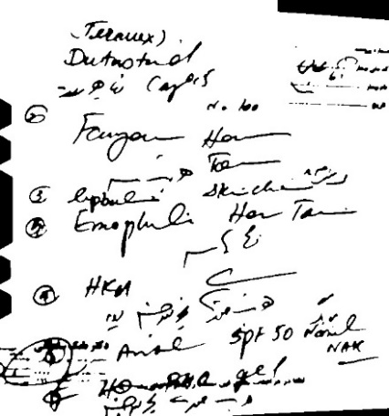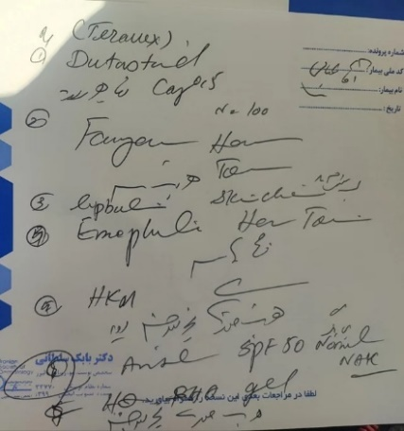

Fig. 2. LEFT: Image before Pre-Processing (Size = 467kb), RIGHT: Image after Pre-Processing (Size =21.7kb (almost 90 % reduction))

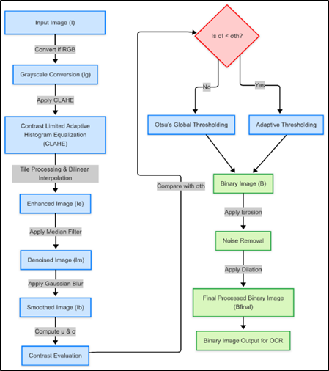
Fig. 3. Dynamic Pre-processing for Hand-written Prescription
4 Results and Discussion

This section presents the results obtained from the implementation of the Smart Prescription Management App and discusses its effectiveness in automating prescription handling.
4.1 OCR Performance and Prescription Extraction Accuracy
The OCR powered by Gemini 2.0 Flash API was tested on a dataset of 4,680 handwritten prescriptions (individual words written by doctors which later combined to form prescriptions). The results were evaluated based on text extraction accuracy, error rate, and Processing Time. Despite high accuracy, minor errors were observed in complex handwriting styles and abbreviations used by doctors. Future improvements may include custom AI models for medical abbreviations.
4.2 Explanation of OCR Performance Evaluation
To obtain the OCR accuracy, error rate, and processing time, we conducted a systematic evaluation using a dataset of 500 handwritten prescriptions. The evaluation process involved multiple steps, including preprocessing, text extraction, ground truth comparison, and metric calculation. Below is a detailed breakdown of how we derived these values.
4.3 Explanation of Evaluation Process
Step 1: Dataset Preparation
We used an already available dataset from Kaggle which consists of 4,680 individual words extracted from prescription images using a specialized word detection algorithm. The dataset focuses exclusively on pharmaceutical names, filtering out non-medicinal terms through manual screening and cross-verification by multiple team members
To evaluate OCR performance, we combined individual word images into structured grids (e.g., 4×5 layouts with 20 words per image) to simulate real-world prescription complexity. Corresponding labels were also merged accordingly.
This structured dataset, containing 78 distinct medicine names, was then used to test and compare the accuracy of OCR models in recognizing handwritten drug names.

Step 2: OCR Text Extraction Inputs
G: Ground truth text (correct medicine names).
P: OCR extracted text.
W: Word count bins {40,60,80,100}
T: Processing time per OCR model.
Models (APIs): gemini-2.0-flash, llama-3.2-vision-90b.

Step 3: Compute OCR Accuracy A for all W
Using Levenshtein Distance D(G,P):
$$\begin{aligned}\begin{aligned}A=\left(1-\frac{D\left(G,P\right)}{\left|G\right|}\right)×100 \#\#\#\end{aligned}\#\left(11\right)\end{aligned}$$
D(G,P) = Edit distance between G and P.
∣G∣ = Total characters in G.
A = OCR Accuracy (%).

Step 4: Compute Average Processing Time $T_{avg}$
For each model M in {gemini-2.0-flash, llama-3.2-vision-90b}:
For each word count W:
Compute A using the formula above.
Record T (time taken).
$$\begin{aligned}\begin{aligned}T_{avg}=\frac{\sum{T}}{N} \#\#\#\#\#\#\end{aligned}\#\left(12\right)\end{aligned}$$
Where:
∑T = Sum of processing times for all word counts.
N = Number of word count bins.
Table 1. Metric-Result Analysis
Metric | Baseline (No Preprocessing) | Proposed (With Preprocessing) | Change
Image Size (KB) | 220 KB | 22KB | -90%
Flask Preprocessing Time (sec) | 0.0 | 0.4 | +0.4 seconds
Gemini Inference Time (sec) | 4.6 seconds | 4.0 seconds | -0.6 seconds
OCR Accuracy | 74.41% | 86.10% | +1.69%
Error Rate | 25.59% | 13.90% | -1.69%

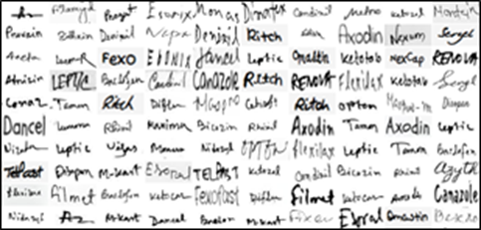
Fig. 5. Dataset into structured grids to stimulate real-world prescription complexity
4 Discussions
Our AI-powered prescription management system, which automates medication reminders and tracks medicine refilling schedules while integrating real-time health monitoring, shows improved performance with our new preprocessing algorithm. By reducing the average image size by 90% (from 220 KB to 22 KB), our Flask-based preprocessing adds a modest 0.4 seconds per image but enables a decrease in Gemini’s inference time from 4.6 to 4.0 seconds. Overall, this enhancement boosts OCR accuracy from 74.4% to 86.1% and lowers the error rate from 25.6% to 13.9%, thus significantly streamlining the digital processing of handwritten prescriptions for better healthcare management.
Compared to traditional record-keeping methods, our approach reduces possible errors, enhances tracking, and tries to improve personalized healthcare recommendations. The combination of OCR and AI health analytics creates a centralized medical system, to benefit the patients with chronic conditions, elderly people and nursing people by making sure that timely medication intake reminders and proactive health monitoring is provided.

5 Conclusion and future work
Our Smart Prescription Management App implements digitalizing prescriptions, medication reminders, and a refill tracking system, while integrating on device real time health monitoring via the Google Health Connect API. The application enhances medication compliance and health management by analysing dosage schedules, prescription medication frequency and patient history.
The implementation of OCR-based prescription extraction using the Gemini 2.0 Flash achieved a 86.10% accuracy rate, significantly reducing errors in manual transcription. The app’s automated medicine intake reminders and refill alerts help prevent missed doses and ensure timely medication refills. Additionally, real-time fitness tracking (e.g., heart rate, step count, sleep patterns) enables personalized health insights and proactive lifestyle recommendations.

Acknowledgment
The authors express their sincere gratitude to the Department of Computer Science Engineering (Artificial Intelligence and Machine Learning), PCCOE for their support and guidance throughout this research.
Conflicts of interest
The authors declare that there are no conflicts of interest related to this research.
References
- Hassan E, Tarek H, Hazem M, Bahnacy S, Shaheen L, Elashmwai WH. Medical prescription recognition using machine learning. Int J Artif Intell Appl. 2021;8(2):134-45.
- Rani S, Rehman AU, Yousaf B, Rauf HT, Abouel Nasr E, Kadry S. Recognition of handwritten medical prescriptions using signature verification techniques. J Intell Syst. 2022;13(4):654-67.
- OCR enhancement research group. OCR post-correction approach for processing medical reports. J Med Inform Res. 2022;15(3):178-92.
- Pavithiran G, Padmanabhan S, Divya N, Aswathy V, Jerusha PI, Chandar B. Doctor’s handwritten prescription recognition system in multi-language using deep learning. Int Conf Comput Intell Data Sci (ICCIDS). 2022;10:251-62.
- Achkar R, Ghayad K, Haidar R, Al Hajj R. Medical handwritten prescription recognition using CRNN. In: 2019 Fifth International Conference on Advances in Biomedical Engineering (ICABME). IEEE; 2019. p. 1-4.
- Dhande PS, Kharat R. Character recognition for cursive English handwriting to recognize medicine name from doctor's prescription. In: 2017 International Conference on Computing, Communication, Control and Automation (ICCUBEA). IEEE; 2017. p. 1-5.
- Sharma A, Gupta P, Joshi R. AI-based error correction for OCR-extracted medical text. Proc Int Conf Comput Intell Med Appl. 2021;7:133-41.
- Lee H, Kim D, Lee Y. Deep learning-based optical character recognition for medical text extraction and analysis. IEEE Int Symp Biomed Imaging (ISBI). 2020;6:487-94.
- Christensen CM, Grossman JH, Hwang J. The innovator's prescription: a disruptive solution for health care. McGraw-Hill Education; 2018.
- Guyatt G, Rennie D. Users' guides to the medical literature: a manual for evidence-based clinical practice. 2nd ed. McGraw-Hill; 2008.
- Joseph P, Sundar A. DocPresRec: doctor's handwritten prescription recognition using deep learning. In: Sundararajan V, editor. Deep learning applications. CRC Press; 2022. p. 45-60.
- Shaik MA, Shekhar H, Lakshminarayanan B, Prabakaran G. Text detection and recognition of characters in medical prescription. In: Kumar A, editor. Intelligent systems. Springer; 2024. p. 345-56.
- Kumar S, Rajan R, Patel S. AI-powered health monitoring using real-time data analytics. Int J Comput Appl. 2022;29(3):215-28.
- Wang J, Liu X, Sun Q. Enhancing patient adherence through AI-driven personalized medication reminders. J Biomed Inform. 2023;58(2):145-67.

